ACTUALIZAR BACKEND:
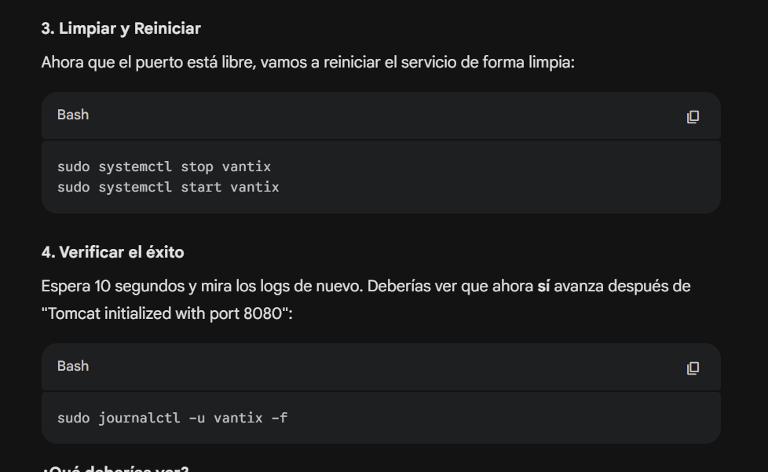
sudo systemctl stop vantix
sudo systemctl start vantix
sudo journalctl -u vantix -f

